Prolog Program to Sum Integers from 1 to N
Aim
To write a Prolog program to calculate the sum of integers from 1 to N.
Objectives
- To understand recursion in Prolog.
- To calculate the sum of natural numbers.
- To implement arithmetic operations in Prolog.
Algorithm
- Start.
- Read the value of N.
- If N = 0, return sum as 0.
- Otherwise, recursively calculate the sum from 1 to N-1.
- Add N to the previous sum.
- Display the result.
- Stop.
Flowchart
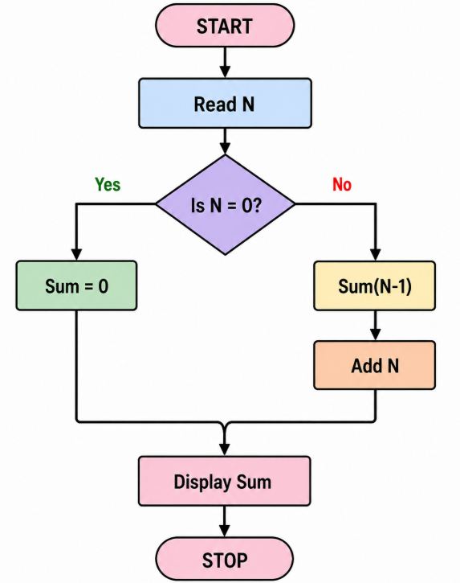

PROGRAM
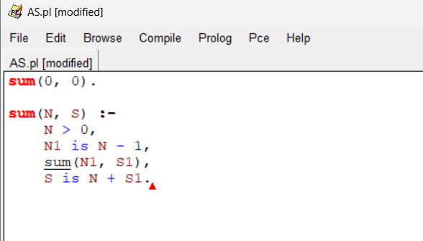

OUTPUT
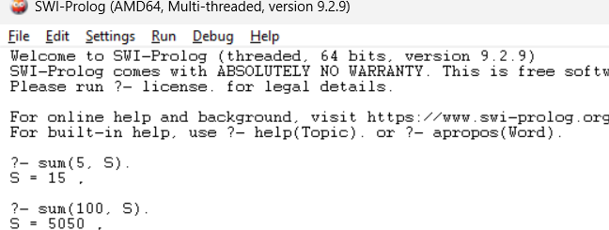

Result
The Prolog program successfully calculated the sum of integers from 1 to N.

